Affordable Housing in Mumbai

Swaha Bhattacharya

2023-05-04

India surpassed China as the most populous contry in the world in April 2023.  
A country with a population of almost 1.43 billion, housing is a huge problem in India, with [approximately 1.8 million people living on the streets](https://borgenproject.org/tag/homelessness-in-india/). The cosmopolitan city of Mumbai is one of the prime examples of rampant homelessness in the country. Each year, [thousands of people from rural parts of India migrate to the city](https://www.bbc.co.uk/bitesize/guides/zgcch39/revision/2#:~:text=economic%20%2D%20more%20jobs%20and%20higher,less%20chance%20of%20natural%20disasters)) for better living conditions and job prospects. This has resulted in Mumbai having a population of more than 21 million, making it one of the most densely populated cities in the world. Consequently, Mumbai has a high demand for housing, but not enough land. This has made [Mumbai the second most expensive city to live in the world](https://www.forbes.com/sites/ellensheng/2017/01/24/the-five-most-expensive-cities-in-the-world/?sh=953cabf61648). [In fact, more than half of the city’s population lives in slums](https://borgenproject.org/tag/mumbai-slums/), which are devoid of basic civic services like water and drainage.

Keeping this in mind, I wanted to look at how affordable housing is in Mumbai.

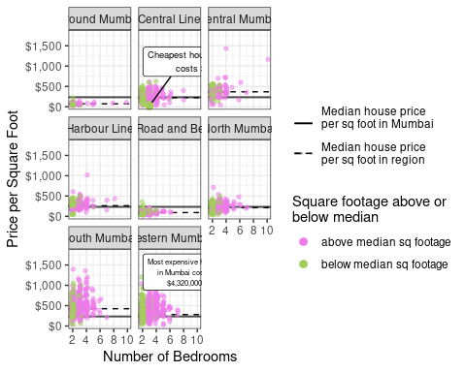

You can also view an interactive version of this visualization at [this](https://swaha294.shinyapps.io/bombay_housing/) link. It allows you to zoom in on popular residential buildings and particular zones in Mumbai.