Six Weeks, 65 Shootings: How Did It Happen?

Shay Iyer

2023-02-08

At 2:00 AM on November 14th, 2022, the majority of my college campus (save for the occasional insomniac) was dozing peacefully. I, however, was on the phone with a friend at the University of Virginia, listening on an iPhone app to police scanners in Charlottesville, Virginia. When the world woke up a few hours later, they were met by the first of many articles about the mass shooter that had taken three lives and left two injured in a University of Virginia campus garage. The shooter would be taken into custody later that morning.

Until then, I was 500 miles away, praying for the first time in a decade for the safety of my friends and colleagues.

Despite countless anecdotes like mine, 2023 is shaping up to be a record year for American mass shootings. As of February 12th, 66 mass shootings have already been [reported nationwide.](gunviolencearchive.org/reports/mass-shooting?page=2), according to the Gun Violence Archive. Over 100 mass shooting deaths and six weeks into the new year, the question rings louder than ever: how did America let it get this far?

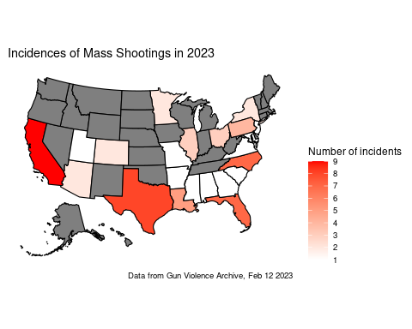

Mass shootings in the United States are common to the point where canned responses of ‘thoughts and prayers’ elicit more [parody](https://knowyourmeme.com/memes/thoughts-and-prayers) than appreciation, even from celebrities. The not-for-profit organization Gun Violence Archive. [defines mass shootings](https://www.gunviolencearchive.org/about) by numbers: if 4 or more people, not including the people, were shot or killed during the event.

To date, however, American legislation has prioritized the right to bear arms as early as the Constitution. At the federal level, firearms safety legislation has been [at war](https://giffords.org/lawcenter/gun-laws/policy-areas/other-laws-policies/key-federal-regulation-acts/) with gun buyers as early as 1986, when the Firearms Owners’ Protection Act annihilated many public safety provisions imposed by the Gun Control Act of 1968. The two-step US purchasing process takes mere hours; until 2019, most Americans could even impulse-purchase a gun at their [local Walmart](https://www.washingtonpost.com/business/2019/09/03/status-quo-is-unacceptable-walmart-will-stop-selling-some-ammunition-exit-handgun-market/)

Other countries’ legislation, on the other hand, often spans months and often requires constant renewal for the maintained possession of a firearm. Japan’s 13-step gun purchase process comes complete with multiple training classes, a written exam (required every three years) and safety regulations that extend to gun storage and background review.

The effects of these extra steps are reflected in the sheer frequency of mass shootings between America and Japan. The deadliest shooting by a single gunman in Japan occurred [in 1938](https://devastatingdisasters.com/tsuyama-massacre-1938/), and there have been two statistically defined mass shootings in the country since (once in [2007](https://www.upi.com/Top_News/2007/12/15/Suspected-Japanese-gym-shooter-found-dead/24641197776777/), the other in [2010](http://www.china.org.cn/world/2010-01/13/content_19227159.html).

In near-blinding contrast, the United States has seen [402 mass shootings from 1966 to 2020](https://rockinst.org/gun-violence/mass-shooting-factsheet/); while only 12 occurred from 1966 to 1975, the country experienced 160 mass shootings between 2011 and 2020.

Concerned citizens like Lillian Bryer, a Biomedical Engineering PhD student at the University of Virginia School of Medicine, are still healing from trauma months after their own mass shooting experiences.

“I felt scared and unsafe in my own community,” Bryer explained. “I had no idea what was happening, and no idea if I would be able to talk to many of my loved ones again.”

Perhaps a Japanese approach to gun control is exactly what should be prescribed for America, a country stuck in perpetual mourning. With just over ten months left in 2023, thousands of Americans’ lives have been placed on the line. Countless more have stories like mine: waiting with bated breath and hands folded, desperately tuning into police scanners. How much more violence has to happen for something to change?